SUPPLEMENTARY INFORMATION

Within-laboratory SARS-CoV-2 real time PCR testing operations in Nepal: a simulation-based analysis

Fannie L. Côtéª, Nadia Lahrichiª*, Erica Gralla^{b}, Hannah Bakker^{c}, Parvathy Krishnan Krishnakumari ^{d,e}, Joaquim Gromicho^{d,e,f}, Arunkumar Govindakarnavar^{g}, Runa Jha^{h}, Lilee Shrestha^{h,i}, Nirajan Bhusal^{g}, Saugat Shrestha^{g}, Rashmi Mulmi^{g}, Priya Jha^{g}, Reuben Samuel^{j}, Dhamari Naidoo^{j}, Victor J del Rio Vilas^{k}

The Lancet Regional Health—Southeast Asia 2025

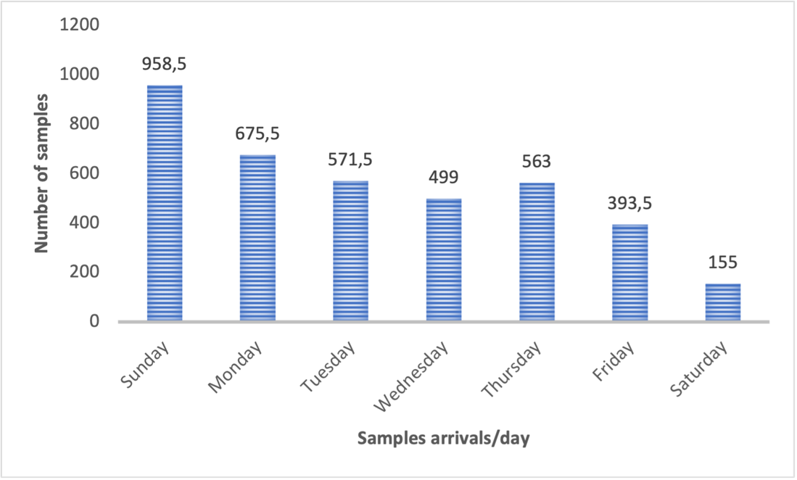
Supplementary Figure 1: Distribution of average sample arrivals per day of week, November 2020 for Provincial Public Health Laboratory – Gandaki (Situation reports, Government of Nepal Ministry of Health and Population). All three weeks have a similar arrival pattern. In Nepal, the workweek is Sunday through Friday, so very few tests are processed on Saturdays.

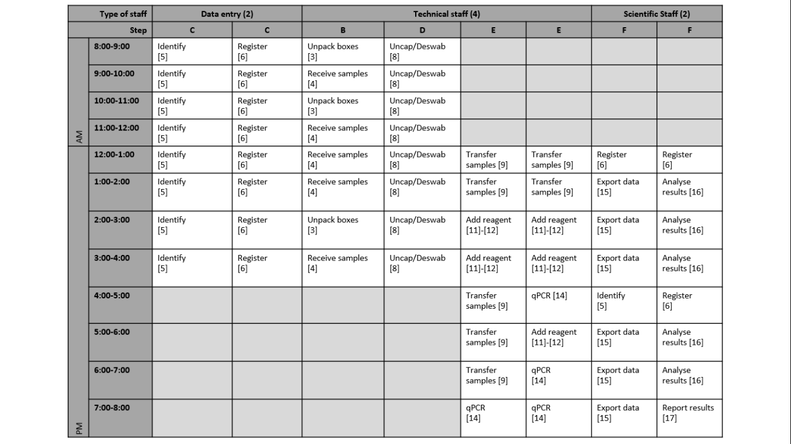
Supplementary Figure 2: Illustration of the schedule used in the baseline scenario. It employs a staggered schedule in which some staff work an earlier shift, and others work a later shift.

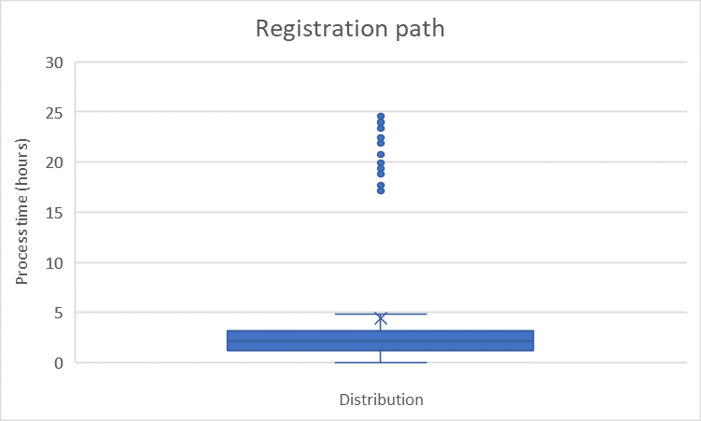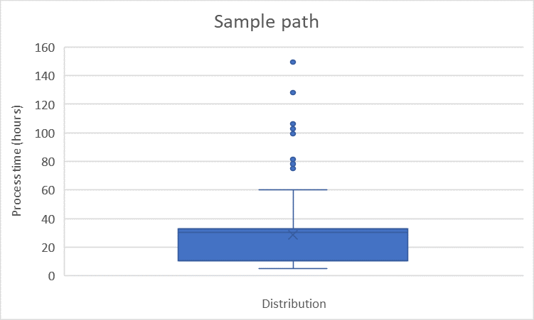

Supplementary Figure 3: Distribution of process times in hours for the registration path and sample path (see Figure 1) for 20 replications, produced by the validated model. Distributions like these were shared with experts as part of the validation process.
Note : The boxplots illustrate the distribution of processing times. The box shows the 25th to 75th percentile range, the whiskers the range of the distribution, and the points the outliers.

