Supplemental materials
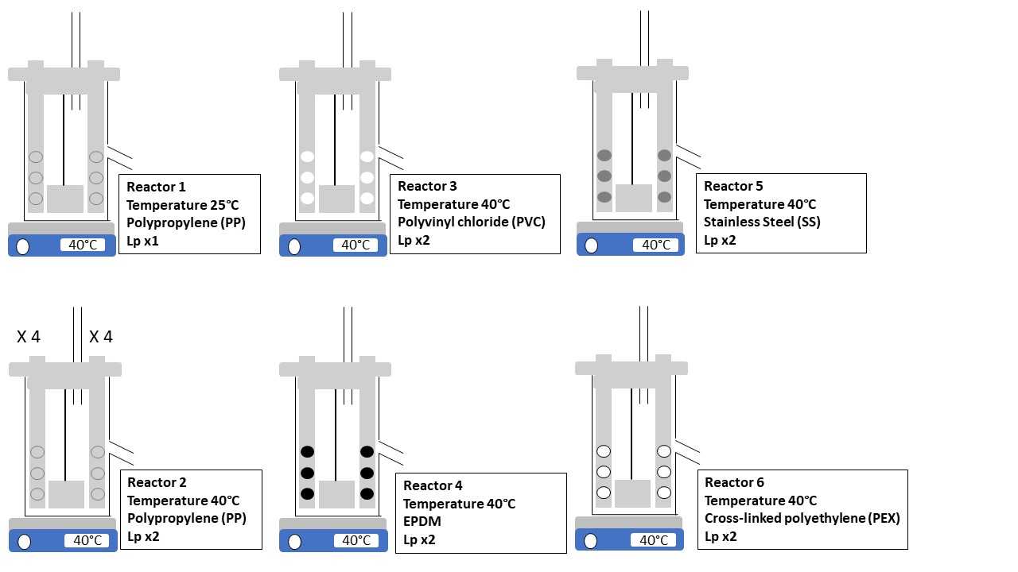
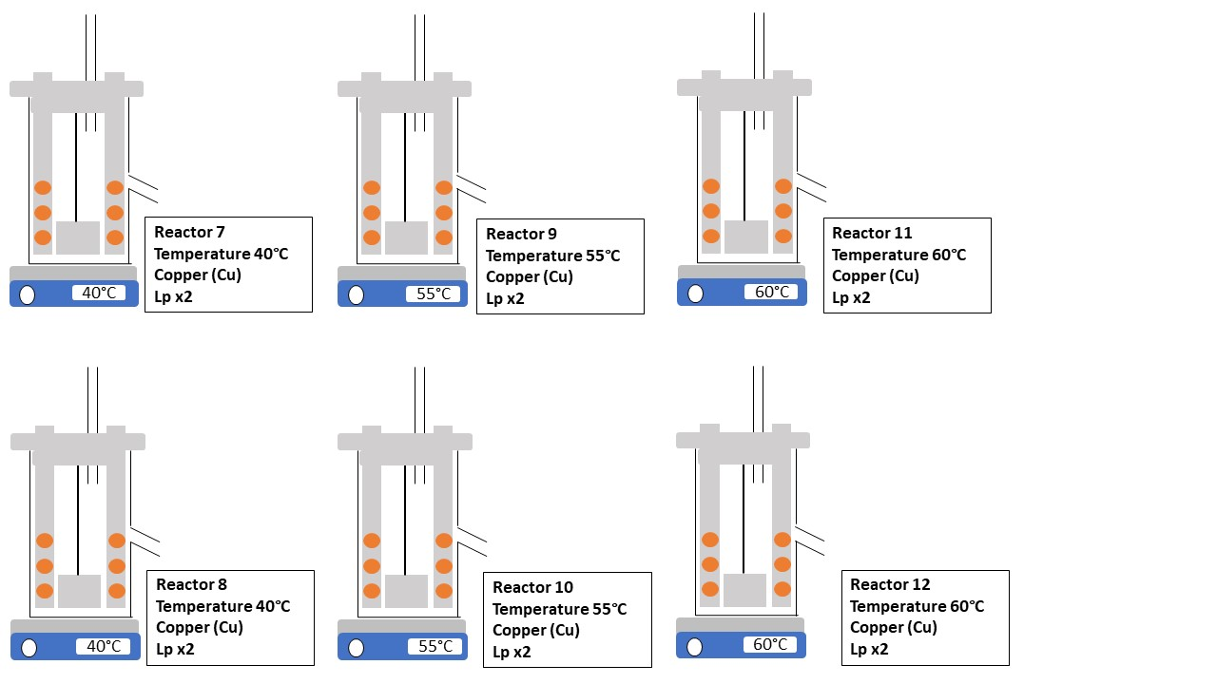
Figure S.1: Scheme of the 12 CDC Biofilm reactors used in this pilot study. Small rigid autoclavable tubing on reactor tops allowed air exchange.
Table S.1: Mean values and standard deviations of physicochemical parameters in the 12 reactors. n represent the numbers of values used for the calculations of the mean and standard deviations in each reactor. Turbidity measurements indicated in italics are the peak values measured and the week the measurements were obtained.
 | Feed | PP_A | PP_B | PVC | EPDM | SS | PEX | Cu_A | Cu_B | Cu_C
pH  n = 20 | 8.08 ± 0.39 | 8.34 ± 0.19 | 8.47 ± 0.18 | 8.47 ± 0.17 | 8.42 ± 0.19 | 8.48 ± 0.16 | 8.47 ± 0.16 | 8.50 ± 0.17 | 8.55 ± 0.25 | 8.54 ± 0.26
Turbidity (NTU)  n = 20 | 0.18 ± 0.08 | 0.37 ± 0.39  w14 = 1.25  w37 = 1.45 | 0.53 ± 0.51  w14 = 1.21  w24 = 2.23  w37 = 1.21 | 0.44 ± 0.46  w14 = 1.54  w22 = 0.76  w37 = 1.77 | 1.57 ± 1.46  w14 = 5.88  w22 = 4.69 | 0.43 ± 0.29  w14 = 0.79  w27 = 1.02  w37 = 0.96 | 0.40 ± 0.27  w14 = 1.03  w22 = 0.86 | 0.66 ± 0.49  w14 = 1.85  w72 = 1.72 | 1.17 ± 1.52  w14 = 2.35  w22 = 6.53 | 0.94 ± 1.65  w14 = 1.31  w22 = 7.88
Dissolved O2 before ↗ T° (mg/L)  n = 6 | 8.63 ± 0.39 | 8.41 ± 0.44 | 8.37 ± 0.40 | 8.41 ± 0.39 | 8.30 ± 0.37 | 8.38 ± 0.46 | 8.34 ± 0.44 | 8.40 ± 0.40 | 8.44 ± 0.41 | 8.39 ± 0.41
Dissolved O2 after ↗ T° (mg/L)  n = 5 | 8.15 ± 0.52 | 7.81 ± 0.49 | 6.73 ± 0.34 | 6.77 ± 0.29 | 6.70 ± 0.25 | 6.65 ± 0.14 | 6.62 ± 0.13 | 6.72 ± 0.15 | 6.11 ± 0.27 | 6.16 ± 0.81
Conductivity (S/m)  n = 20 | 391 ± 30 | 395 ± 36 | 396 ± 38 | 402 ± 38 | 402 ± 40 | 404 ± 39 | 402 ± 44 | 393 ± 51 | 396 ± 35 | 394 ± 36
Free Chlorine 24H after shock chlorination (mg/L) | / | 15.6 | 15.4 | 15.6 | 3.4 | 13.8 | 13.7 | 11.3 | 10.6 | 12.8
DOC (mg/L)  n = 11 | 1.89 ± 0.23 | 2.65 ± 0.62 | 3.12 ± 1.03 | 3.12 ± 1.09 | 4.14 ± 2.04 | 3.08 ± 1.04 | 3.80 ± 3.28 | 2.89 ± 0.98 | 3.93 ± 2.58 | 4.68 ± 3.32
BDOC (mg/L)  n = 10 | 0.12 ± 0.05 | 0.29 ± 0.16 | 0.41 ± 0.30 | 0.46 ± 0.40 | 0.66 ± 0.91 | 0.46 ± 0.42 | 0.50 ± 0.43 | 0.37 ± 0.22 | 0.92 ± 1.06 | 1.23 ± 1.33

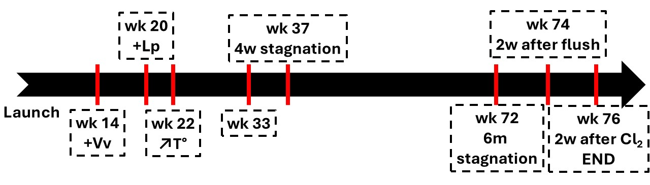
Figure S.2: Schematic of the timeline of the pilot’s operation
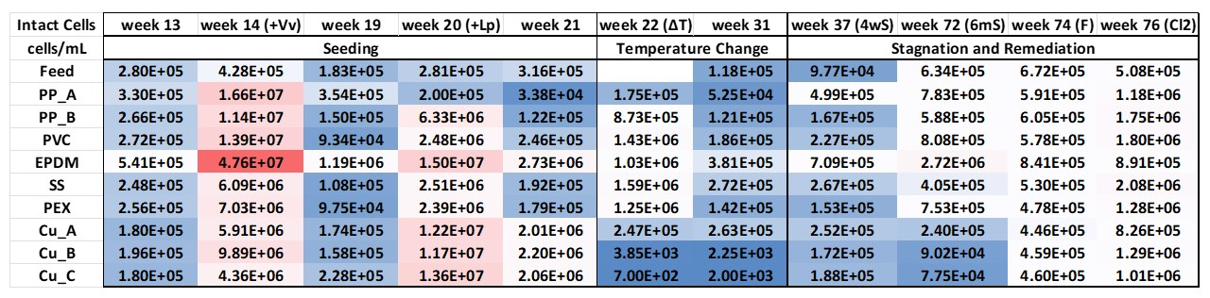
Figure S.3: Heatmap of intact cells densities in all the reactors and the feed water. Lowest values are in blue while higher ones are in red. Samples were collected three days after interventions (+Lp, +Vv and ΔT) and 2 weeks after flushing (F) and chlorination (Cl₂). Cu_A reactors were heated at 40°C, Cu_B at 55°C and Cu_C at 60°C during the heating phase.

