Journal: Environmental Science and Pollution Research
Article Title: Removal of nickel from neutral mine drainage using peat-calcite, compost, and wood ash in column reactors

Authors: Dominique Richard¹, Carmen Mihaela Neculita³, Gérald J. Zagury^{1*}
¹ Research Institute on Mines and Environment (RIME), Polytechnique Montréal, QC, Canada
³ RIME, University of Quebec in Abitibi-Temiscamingue (UQAT), 445 Boul. de l’Université, Rouyn-Noranda, QC, J9X 5E4, Canada
*corresponding author
Email: gerald.zagury@polymtl.ca, Tel: +1 514 320 4711 ext: 4980, Fax: +1 514 340-4477

Determination of hydraulic parameters
During column experiment, flow rates were kept constant in order to avoid undesirable geochemical perturbations to the dynamic system, and therefore, the measurements of hydraulic parameters were limited to the use of these experimental flow rates. Measuring the hydraulic conductivity of the relatively high conductivity materials of this study using low flow rates was difficult and sometimes impossible due to the small (<0.4cm) to inexistent difference in head. During initial hydraulic conductivity measurements on the gravity fed up-flow setup, an origin-based linear correlation was observed between the flow rates and gradients measured during hydraulic conductivity tests on wood ash (R² = 0.79) and peat-calcite (R² = 0.68) columns, confirming the validity of these initial k_{sat} measurements. This correlation was not present during hydraulic conductivity tests with the C2 column. Final hydraulic conductivity measurements were performed under synthetic CND feed to avoid using distilled water and perturbing the system’s geochemistry. During these measurements, the height of head in piezometers (58.7-63.6 cm) were lower than for hydraulic conductivity tests with distilled water (85.9-86.3 cm), but the difference in head between piezometers was comparable.
Table S1 Elemental composition (mg/kg) of solid organic materials.
Parameter | Peat | Compost | Wood ash
Al | 2700 | 42000 | 9000
As | 0.3 | 6.5 | 12.9
Ba | 130 | 490 | 1100
B | 36 | 25 | 110
Be | <DL | 0.74 | <DL
Bi | <DL | 2.9 | <DL
Ca | 4900 | 52000 | 130000
Cd | 0.11 | 0.54 | 4.4
Co | 0.4 | 6.4 | 3.9
Cr | 3 | 42 | 3.5
Cu | 2 | 120 | 64
Fe | 2000 | 19000 | 4100
K | 930 | 12000 | 19000
Mg | 3000 | 10000 | 10000
Mn | 35 | 420 | 3800
Mo | 0.16 | 2.6 | 5.9
Na | 2000 | 10000 | 4500
Ni | 1.3 | 16 | 14
Pb | 1.3 | 48 | 12
Sb | <DL | 1.1 | <DL
Se | 0.43 | 1.3 | <DL
Sn | <DL | 7 | <DL
Ti | 120 | 1000 | 380
Zn | 31 | 270 | 510

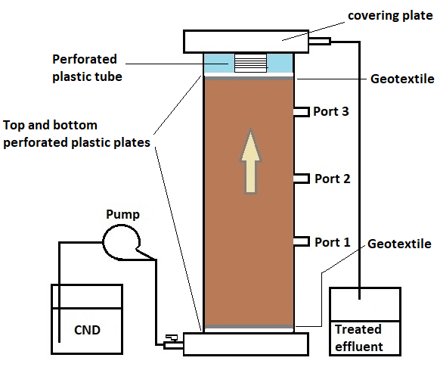
Figure S1 Setup of up flow column reactors

Figure S2. (A) Initial hydraulic conductivity measurements inside the gravity fed columns under varying gradients. (B) Final hydraulic conductivity measurements inside the synthetic CND fed columns as a function of flow rates.

Figure S3. Sulfate breakthrough curves measured at the outlet port during tracer test. Dashed line represents the mean inflow sulfate concentration.

Figure S4. Normalised sulfate breakthrough curves measured during tracer test with Sauty dimensionless-type curve fits. In these curve fits, t_{HRT} corresponds to HRT_{exp(48h)} values. P_{e} number was determined graphically by manually varying this parameter until the dimensionless curve was adjusted to the experimental data.

Figure S5. Nickel speciation in synthetic CND as a function of pH under closed system conditions using data from Table 1 ([Ni]_{tot} = 4.05 mg/L or 69 μmol/L). Species with concentrations below 1 μmol/L are not presented.

Figure S6. Outflow cation and sulfate concentrations during column experiments. Mean inflow cation and sulfate concentrations are represented by the straight dashed line. Iron concentrations were not analysed in the first 6 weeks of the compost experiment.

Figure S7. Final pore water nickel concentrations in columns taken at time =11 weeks for the wood ash and peat-calcite columns and at time = 17 weeks for the compost columns. The y axis represents the height of the sampling port in columns.

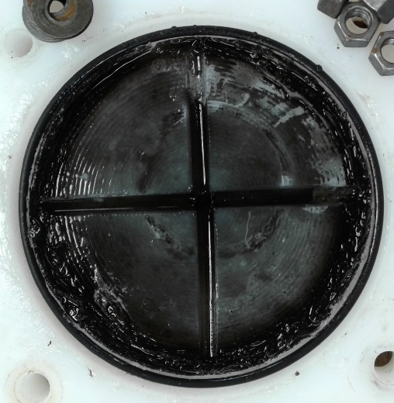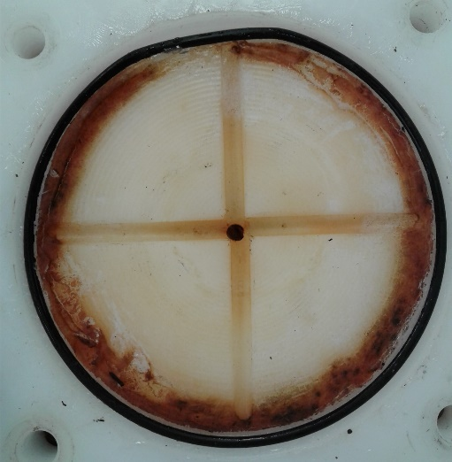
(B)
(A)
Figure S8. Iron precipitates on one of the compost columns top covering plate. Pictures taken (A) the day of dismantlement and (B) two weeks after dismantlement.

Table S2 Nickel concentrations in extracting solutions following SEP of spent organic materials sampled from bottom and top sections of columns at dismantlement. An operational definition of each fraction can be found in text.
 |  |  | Bottom  (mg/kg)¹ | Middle  (mg/kg)² | Top  (mg/kg)¹
Wood ash |  | F1 | 69 ± 20 | 11 | 11 ± 1
 |  | F2 | 768 ± 124 | 18 | 18 ± 1
 |  | F3 | 2150 ± 500 | 19 | 21 ± 2
 |  | F4 | 444 ± 46 | < DL | 1.5 ± 1.1
 |  | F5 | 62 ± 20 | 7 | 14 ± 3
Compost |  | F1 | 418 ± 28 | 8.5 | 4.8 ± 0.2
 |  | F2 | 781 ± 92 | 25 | 5.7 ± 1.0
 |  | F3 | 1220 ± 20 | 123 | 7.7 ± 2.2
 |  | F4 | 802 ± 51 | 142 | 14 ± 5
 |  | F5 | 76 ± 9 | 19 | 19 ± 3
Peat-calcite |  | F1 | 835 ± 28 | 228 | 5.4 ± 0.8
 |  | F2 | 750 ± 68 | 346 | 6.3 ± 2.3
 |  | F3 | 1380 ± 95 | 641 | 6.3 ± 6.0
 |  | F4 | 1866 ± 92 | 1030 | 33 ± 31
 |  | F5 | 77 ± 10 | 21 | 3.9 ± 0.6
¹Results are expressed as mean ± standard deviation of the [Ni] from n = 2 (duplicate columns). ²Results obtained with single samples from columns C2, PC2, WA1.

Figure S9. Temporal evolution of calcite saturation indexes according to Vminteq modelling performed using the monitored parameters (pH, E_{H}, alkalinity, DOC, Ca²⁺, Mg²⁺, K⁺, Na⁺, Mn²⁺, Fe²⁺, SO₄²⁻ and Cl⁻ ) in treated waters.

