**Removal of nickel from neutral mine drainage using peat-calcite, compost, and wood ash in column reactors**

Dominique Richard1, Carmen Mihaela Neculita2, Gérald J. Zagury1*

1 Research Institute on Mines and Environment (RIME), Civil, Geological, and Mining Engineering Department, Polytechnique Montréal, H3C 3A7, QC, Canada   
2 RIME, University of Quebec in Abitibi-Temiscamingue (UQAT), 445 Boul. de l’Université, Rouyn-Noranda, J9X 5E4, QC, Canada  
*corresponding author Email: [gerald.zagury@polymtl.ca](mailto:gerald.zagury@polymtl.ca), Tel: +1 514 320 4711 ext: 4980, Fax: +1 514 340-4477

**Abstract**

The effectiveness of compost, peat-calcite and wood ash to remove Ni from a circum-neutral contaminated mine water was tested in continuous flow experiments. Materials were compared in 4.8 L columns at hydraulic residence times (HRT) of ∼ 16.5 hours over the course of 2.5-4 months. During this period, all columns successfully treated over 400 L of synthetic contaminated neutral drainage (4.05 mg/L Ni), mainly through sorption processes. Mid-column results (HRT ∼ 9 hours) indicated that wood ash was the most effective material for Ni removal and chemical extractions revealed that retained Ni was less mobile in this spent material. The pH-increasing properties of wood ash played a major role in this material’s performance, but a pH correction would be required in the initial stages of full scale treatment to maintain the effluent within regulatory limits (6-9.5). Scaled to full size, mid-column results indicated that treatment cell sizes, designed for the one-year treatment of a high discharge (10 m3/h) contaminated effluent (4.05 mg/L Ni), would be smallest with wood ash (< 500 m3), followed by compost (600 ± 140 m3) and peat-calcite (720 ± 50 m3).

**Keywords:** Neutral mine drainage, columns, Ni, sorption, hydraulic retention time, organic materials.

**Introduction**

Contaminated neutral drainage (CND) is a mine drainage characterized by pH values ranging between 6 and 9 and metal concentrations that exceed local regulatory discharge limits levels (Nordstrom et al. 2015). It can arise when the acidity resulting from the oxidation of sulfide minerals is buffered by the presence of carbonate or silicate minerals in the gangue rock and the resulting composition varies depending on the mineralogy of each particular mine site. CNDs are typically characterized by high concentrations of major cations (Na+, K+, Ca2+, Mg2+) as well as distinct but relatively low concentrations of potentially toxic metals. Ni is often present in CND and its ecotoxicity is mainly attributed to its free cation Ni2+ species which is predominant at circum-neutral pH (Stokes 1988).The main difficulties for CND treatment are the variable effluent compositions encountered, the remoteness of mining sites and the specific particularities of each site (e.g., topography, temperature) (Calugaru et al. 2018)

The implementation of gravity-fed passive reactors is considered a cost-effective technology to treat mining effluents after mine site closure. Inside these reactors, low-cost reactive materials interact with the contaminated effluent and dissolved metals can be sequestered on the substrate, via sorption mechanisms, or within the voids by precipitation mechanisms such as direct precipitation, co-precipitation or sorption onto newly formed precipitates (Neculita et al. 2008). Much of the knowledge concerning passive reactors comes from the treatment of acid mine drainage (AMD) for which the two most used systems are organic substrate based reactors (ex. passive biochemical reactors), promoting sulfate reduction and metal sulfide precipitation, and alkaline substrate based reactors, promoting metal hydroxide and carbonate precipitation (Skousen et al. 2017). Passive biochemical reactors typically require voluminous treatment systems with long hydraulic residence times (HRT), on the order of days, to achieve metal sequestration by sulfide precipitation (Neculita et al. 2007). Less voluminous systems, with HRTs on the order of minutes or hours, designed to promote sorption could be an economically viable option for the treatment of the typically lower metal and sulfate concentrations of CND.

Treatment strategies based on precipitation are highly dependent on HRT as the contact time between the substrate and the influent water influences the concentration of dissolved species in the pore water, and insufficient exposure time may not activate the desired precipitation reactions. Furthermore, water velocities, which depend on the HRT and on the system’s configuration, can affect the settlement and compaction of newly formed crystals, and high water velocities resulting from the use of low HRTs can reduce the longevity of the system by creating confined cavity volumes and short-circuiting (Claveau-Mallet et al. 2012). Precipitation based treatment strategies are also highly dependent on the influent water composition as it determines the precipitation reactions and sequestering mechanisms that may be activated by the circulation of this effluent through a reactive substrate. For example, in iron and manganese rich CNDs, precipitation of Fe and Mn (oxy)hydroxides may be used to sequester Fe, Mn as well as other metals that adsorb onto these newly formed hydroxide surfaces (de Repentigny et al. 2018; Trumm and Pope 2015). While treatment by precipitation eventually leads to system failure by clogging or by depletion or passivation of the substrate (Courcelles et al. 2011; Neculita et al. 2007), less is known about sorption-based treatment strategies and how they may be influenced by HRT, water velocity and influent water composition. Sorption reactions typically have high kinetic rates (Ali and Gupta 2006; Richard et al. 2020a; Richard et al. 2013) and therefore the use of shorter HRT and higher water velocities may not affect this type of removal mechanism as strongly. Sorption reactions begin quickly when the influent water is exposed to the substrate (Malamis and Katsou 2013) and thus no minimal contact time should be necessary to activate this mechanism. Nevertheless, HRT remains an important design parameter as precipitates may still form in reactors and enhance or reduce the overall performance of the system.

The low-cost and proximity of substrates to the mining sites have been identified as general guidelines for the selection of materials for passive reactors (Calugaru et al. 2018; Hengen et al. 2014). For mines in close proximity to certain industries such as steel mills and power stations, low cost industrial waste products such as steel slag and ash may offer potential as alkaline substrates (Calugaru et al. 2017; de Repentigny et al. 2018; Warrender et al. 2011). For remote mining sites, natural locally available materials such as peat, compost and carbonate rocks might be an efficient and cost-effective option (Richard et al. 2020b). In passive systems designed to treat contaminated water after mine site closure, the reactive materials are typically used in a single, long-term treatment cycle (years ideally) before being disposed of. Studies comparing the longevity of different reactive materials under continuous flow conditions are scarce and, to the authors’ knowledge, only one field pilot study by Warrender et al. (2011) compared low-cost materials for the treatment of a CND. Further work is required to identify the most promising low-cost substrates and designs for the treatment of CND in short-HRT systems.

In this study, three organic materials (wood ash, compost and calcite-amended peat) were compared in short-HRT (16.5 hours) column experiments for the treatment of a Ni contaminated neutral drainage. The objectives were to (1) compare the performance of the three materials for the removal of Ni and (2) gain insight into the removal mechanisms for the different types of substrates.

**Material and methods**

*Organic materials characterization and preparation*

The compost was produced from green waste and was provided by the City of Montreal (Québec, Canada). The wood ash (particles < 5 mm), a mixture of bottom and fly ash from a wood and gas co-generation plant, was provided by Wood Ash Industries (Kirkland Lake, Ontario). The sphagnum peat moss was purchased from a local retailer (Home Depot, Montreal, Quebec). Materials were air dried, and the compost and peat moss were sieved to less than 5 mm. All organic materials were kept at room temperature in plastic containers until use. The pH (2 g substrate: 100 mL deionized water) was measured after mixing thoroughly for 20 seconds and letting stand for 1 hour. All pH measurements were carried out with a combination glass electrode (model Orion 9156BNWP, ThermoScientific), calibrated using three NIST-traceable buffer solutions (4.01, 7.00, and 10.00 at 25 °C), and a pH meter (model Orion Star A211 benchtop, ThermoScientific). The cation exchange capacity (CEC) of each substrate was determined in 1M NaOAc at pH 8.2 as per Chapman (1965). The total carbon (CTOT) and total organic and graphitic carbon (Corg+g) were measured by combustion at 1400 °C in an induction furnace (model CS744, LECO Corporation) according to Ma. 310-CS 1.0 (CEAEQ 2013). Total organic and graphitic carbon (Corg+g) sample was prepared by dissolution of the solid inorganic carbon for at least one hour in a 50 % v/v HCl solution, filtering and analyzing the residual solid. Dissolved organic carbon (DOC) was analyzed on filtered (0.45 μm) extracts of slurries (20 g substrate (wet weight): 200 mL deionized water) shaken for 2 hours with a rotary agitator (150 RPM) at room temperature. The DOC was determined as the difference between the total and inorganic carbon according to Standard Method 5310 B (APHA 2005), using a DOHRMAN model DC-190 TOC analyzer. Specific surface area (SSA) was measured with a Micromeritics Gemini III 2375 surface analyzer using method BET PE2 AM-05 (Brunauer et al. 1938). The pH, CEC, CTOT, Corg+g, DOC and SSA of fresh materials are presented along with post-column characterization results (Table 3). For wood ash only, the total organic carbon Corg was determined by titration according to MA. 405 – C 1.1 (CEAEQ 2014). The initial metal content of substrates (Table S1, SI) was measured by digesting 1 g (dry weight) of solid in HNO3, HF, and HClO4 in Teflon beakers according to method 3030 I. (APHA 1998) and analyzing filtrates at Maxaam Analytics Inc. laboratories by ICP-MS according to method MA.200-Mét. 1.2 (CEAEQ 2019).

*Column reactor design, set up, operating conditions*

The experimental set-up was comprised of six vertical Plexiglass columns of 12.7 cm inner diameter by 38 cm height, filled with materials (in duplicates): wood ash (WA1, WA2), compost (C1, C2) and peat-calcite (PC1 and PC2). Each column was equipped with the following plastic components: an inlet valve on the base plate, an open outlet port on the covering plate and three intermediate sampling ports equipped with septa located at 9.0 ± 0.2 cm (P1), 18.6 ± 0.3 cm (P2) and 27.9 ± 0.3 cm (P3) (Fig. S1, SI). Perforated plastic plates and geotextiles (0.5 cm/s, Polyfelt TS 500) were used to enclose the materials within the columns, distribute the solution evenly through the base of each column (upward flow) and avoid fines washing. Prior to their insertion in the columns, materials were moistened with distilled water, and peat was mixed with calcium carbonate (ACS reagent grade) at a ratio of 0.1 g CaCO3/g (dry weight). In columns, materials were lightly compacted in successive layers of about 6 cm and water content was determined by collecting at least two samples of the humid substrates and drying them at 60 °C until constant weight was obtained. A perforated plastic tube was placed between the top and covering plates to hold materials in place. The void volume was determined by weight method using the volume of the empty columns and the mass, density and specific gravity (Gs) of the materials (Chapuis et al. 1989). Gs was determined using water pycnometer method D854-14 (ASTM 2014) and porosity was calculated as the ratio between void volume and total volume (Table 1).

Table 1 Physical properties and hydraulic parameters of low-cost organic materials used in column experiments

|  |  |  |  |  |  |  |  |  |
| --- | --- | --- | --- | --- | --- | --- | --- | --- |
|  | Gs | Porosity (%) | Density (g/cm3) | Initial Ksat  (cm/s) | Final Ksat  (cm/s) | Qmean (mL/min) | HRTv  (h) | HRTvP2  (h) |
|  |  |  |  |  |  |  |  |  |
| Wood ash1 | 2.10 ± 0.02 | 88.2 ± 0.3 | 0.25 ± 0.01 | 0.170 ± 0.049 | 0.015 ± 0.003 | 3.86 ± 0.23 | 16.5 ± 0.7 | 9.0 ± 0.1 |
|  |  |  |  |  |  |  |  |  |
| Compost1 | 2.17 ± 0.01 | 69.8 ± 1.2 | 0.66 ± 0.03 | 0.016 ± 0.0052 | 0.018 ± 0.001 | 3.08 ± 0.19 | 16.1 ± 1.0 | 8.9 ± 0.0 |
|  |  |  |  |  |  |  |  |  |
| Peat-calcite1 | 1.60 ± 0.01 | 87.1 ± 0.3 | 0.206 ± 0.005 | 0.057 ± 0.017 | 0.034 ± 0.009 | 3.68 ± 0.17 | 16.5 ± 0.1 | 9.3 ± 0.1 |
|  |  |  |  |  |  |  |  |  |

1Results are expressed as mean ± standard deviation using n = 3 (Gs), n = 2 (porosity, density) n = 5-9 (Initial Ksat), n = 2-6 (Final Ksat), n = 66-109 (Q), n = 2 (HRTv, HRTvP2). 2 Value measured in C2 only as no gradient could be obtained in C1.

After set-up, columns were saturated by vacuuming and filling with distilled water (Chapuis et al. 1989), and gravity fed from bottom to top for a period of 3 to 7 days prior to initial hydraulic conductivity measurements (initial ksat). Water saturation time was longer with peat-calcite than with compost and wood ash due to the hydrophobic properties of peat. The initial hydraulic conductivity was evaluated with the constant-head method D2434-68 ASTM (2000) using gravity fed up-flow setup. For these measurements, open sandpipe piezometers were temporarily installed on P1 and P3 to measure the pore-water gradients within the saturated materials while flow rates were being recorded. Results from several successive determinations under various gradients (0.003-0.05) were used to calculate the initial ksat (Table 1, Fig. S2-A, SI). Following the initial ksat measurements, the columns were fed distilled water by peristaltic pumps (model 7520-35, Masterflex) for a period of 1 to 7 days and flow rates were adjusted to obtain a void volume hydraulic retention time (HRTv) of about 16.5 hours. Additional ksat measurements were conducted under pump feed and were within two standard deviations of the initial ksat values. Overall, the water saturation step lasted 7 days for the compost columns, 8 days for the wood ash columns and 13 days for the peat-calcite columns.

The column experiment was initiated by removing piezometers and replacing the water flow by an upward synthetic CND flow. The experiment lasted 18, 12, and 11 weeks for compost, peat-calcite and wood ash columns respectively. The columns were kept at room temperature (23.3 ± 2.3 °C) for the duration of the experiment and mean flow rates (Qmean) were used to calculate the full (HRTv) and mid-column (HRTvP2) void volume hydraulic retention times (Table 1). Towards the end of the experiment (t = 11 weeks for the wood ash and peat-calcite columns and t = 15 weeks for the compost columns), piezometers were reinstalled and final hydraulic conductivity measurements (final ksat) (Table 1, Fig. S2-B, SI) were performed as synthetic CND was pumped through the columns at the experimental flow rate. Final ksat values were within two standard deviations of initial ksat values for peat-calcite and compost and one order of magnitude lower than initial ksat for wood ash. More details about the determination of hydraulic parameters are presented in SI.

*Water quality, sampling and analysis*

The synthetic CND used as influent in the column experiments was based on the composition of a grab effluent sample from the Lac Tio mine, a low-iron Ni-contaminated drainage originating from the waste piles of a massive ilmenite deposit located near Havre-Saint-Pierre (Québec, Canada) (Table 2). The pH of this effluent is generally between 6.5 and 7.8 and Ni concentrations vary, occasionally exceeding the local provincial regulation (0.5 mg/L and 1 mg/L mean monthly and maximum acceptable concentrations, respectively) if not treated. The synthetic CND was prepared in a 120 L plastic barrel by dissolving salts in distilled water and its Ni concentration (4.05 mg/L), chosen as a worst-case scenario as well as to ensure analytical detection for a few months of column experiments, was much higher than field-measured Ni concentrations.

Table 2. Composition of an unfiltered field sample and of synthetic CND used in column experiments

|  |  |  |  |  |  |
| --- | --- | --- | --- | --- | --- |
| Component | Unit | Lac Tio mine field sample | Synthetic CND1 | DL | Source |
| Ca | mg/L | 251 | 251 ± 9 | - | CaSO4 · 2H2O |
| Mg | mg/L | 64 | 64.5 ± 2.8 | - | MgSO4 · 7H2O |
| Na | mg/L | 66 | 74.7 ± 8.0 | - | NaCl, NaNO3, Na2SO4 |
| K | mg/L | 4.6 | 4.68 ± 0.35 | - | K2SO4 |
| Ni | mg/L | 2.29 | 4.05 ± 0.21 | 0.01 | NiSO4 |
| Zn | mg/L | 0.55 | 0.37 ± 0.08 | 0.01 | ZnSO4 · 7H2O |
| Mn | mg/L | 0.37 | 0.40 ± 0.02 | 0.01 | MnSO4 · H2O |
| Co | mg/L | 0.59 | 0.64 ± 0.02 | 0.01 | CoCl2 · 6H2O |
| SO42- | mg/L | 897 | 917 ± 43 | 0.2 | Ca, Mg, Na, K, Zn and Mn sulfates |
| Cl- | mg/L | 84 | 85.22 | 0.5 | NaCl |
| NO3- | mg/L | 1.92 | 0.82 | 0.2 | NaNO3 |
| Alkalinity | mg/L CaCO3 | 46 | 10.6 ± 0.8 | - | - |
| pH | - | 7.25 | 6.90 ± 0.17 | - | NaHCO3, CO2 |
| Eh | mV | - | 661 ± 14 | - | - |

1Results are expressed as mean ± standard deviation using n = 19 (Ni), n = 14 (other cations and SO4), n = 34 (pH), n = 29 (Eh, alkalinity).2 Cl- and NO3- concentrations were analyzed once by ion chromatography (model Thermo Scientific ICS 5000 AS-DP DIONEX).

The monitored parameters of the influent CND and of the treated water included pH, oxydo-reduction potential (ORP), alkalinity, dissolved organic carbon (DOC), and SO42-, Ni, Ca, Mg, K, Na, Zn, Co, Mn, and Fe concentrations. Samples for pH, ORP, alkalinity and Ni were taken at least bi-weekly at the inlet, mid-column (P2) and outlet ports, while samples for sulfate and other cations were taken at least every 4 weeks at the inlet and outlet ports only. At mid-column ports (HRTvP2 ∼ 9 hours), sampling was performed by inserting a needle in the septum and collecting the out-coming drip. All samples were filtered through 0.45 µm PVDF syringe filters except for pH, ORP and alkalinity determination. The ORP was measured immediately after sample collection using a double-junction Ag/AgCl electrode, (model Cole-Parmer GH-59001-77), calibrated with an ORP standard solution (Orion, ThermoScientific), and pH meter (model Hanna HI-5521). The ORP readings are reported in millivolts (mV) with respect to the Standard Hydrogen Electrode (Eh). The pH was measured within 4 hours of sample collection using a combined glass electrode (model Orion 9156BNWP, ThermoScientific), and pH meter (model Orion Star A211 benchtop, ThermoScientific). The total alkalinity (endpoint pH 4.5) was measured within 24 hours of sample collection according to standard method 2320 B (APHA 1998). Filtered samples for metal analysis were acidified with 1 % HNO3 (v/v), stored at 4 °C, and analyzed by atomic absorption spectrometry (AAS; Perkin-Elmer AAnalyst-200). Sulfates were measured within 30 hours by turbidimetry using a Lamotte (BaCl method 3665-SC, model SmartSpectro) or HACH (SulfaVer 4 method, model DR 6000) spectrophotometer. DOC samples were collected at the outlet by filling 15 mL centrifuge tubes and making sure no air was entrapped in the sample. Samples were stored at 4 °C and analyzed within 48 hours.

Before columns were dismantled, the ORP was measured at all sampling ports (time = 11 week), along with the final dissolved Ni, Fe and sulfide concentrations (t = 11 weeks for wood ash and peat-calcite columns and at t = 17 weeks for compost columns). Sulfides were analyzed within 3 minutes of sampling using a HACH spectrophotometer (USEPA Methylene Blue Method, model DR 6000).

*Tracer test*

In order to confirm the calculated HRTv, seven samples were taken at the outlet port during the initial 48 hours of the CND feed, syringe filtered through 0.45 µm PVDF filters, and analyzed for sulfates in order to obtain breakthrough curves for each column (Fig. S3, SI). Sulfates were used as a tracer because batch experiments (Richard et al. 2020b) have shown that sulfate concentrations remained constant in the presence of the solid substrates and preliminary column experiments have shown that outlet chloride and sulfateconcentrations described CND breakthrough equally well. Experimental hydraulic residence times (HRTexp(48h)) were determined graphically as the time where half of the final outflow sulfate concentration was reached. The HRTv, calculated for the material filled section of the columns, did not include the time of passage (1 to 3 hours) of the CND through the empty section of the columns located between the top perforated plate and the column’s covering plate. For this reason, total void hydraulic retention times (HRTvtot(48h))were determined for each column by combining the HRTv and the empty section HRT, using the flow rates measured during the first 48 hours of the CND experiment. Experimental HRTexp(48h) values(19.5 ± 0.8, 19.7 ± 0.5, and 18.2 ± 1.1 hours for compost, peat-calcite and wood ash respectively) were within 2 hours of the calculated HRTvtot(48h) values (18.4 ± 0.4, 17.8 ± 0.6 and 19.7 ± 0.4 hours for compost, peat-calcite and wood ash respectively).

*Treatment of experimental data*

Mid-column Ni breakthrough results for compost and peat-calcite columns were fit with s-shaped curves using the dimensionless parameter method of Sauty (1980). This method allows an estimation of the Peclet (*Pe*) number using results of continuous injection tracer experiments (Peregoedova 2013). For the continuous injection of a tracer in a unidimensional field, the dimensionless equation for the restitution of the tracer (Eq. 1) is:

$C_{r}\left(t_{r},Pe\right)=0.5\left\{erfc\left({\left(\frac{Pe}{{4t}_{r}}\right)}^{\frac{1}{2}}\left(1-t_{r}\right)\right)-exp\left(P_{e}\right)erfc\left({\left(\frac{Pe}{{4t}_{r}}\right)}^{\frac{1}{2}}\left(1+t_{r}\right)\right)\right\}$ (1)

where *Cr* is the normalized concentration defined as C/C0 (where C0 is the input concentration), *tr* is the normalized time defined as t/tHRT (where tHRT is determined graphically and corresponds to the time when *Cr* = 0.5), and *Pe* is the Peclet number. First, the method was used to estimate the *Pe* number of the materials using the tracer test results (Fig. S4, SI). Second, it was used to fit dimensionless-type curves to normalized mid-column Ni breakthrough results using these predetermined *Pe*numbers. In this model the normalized volume V/VHRT (where VHRT is determined graphically and corresponds to the volume of CND treated when *Cr* = 0.5)was used instead of *tr*.

*Post-testing characterization*

Columns were dismantled after 127 days (compost), 85 days (peat-calcite) and 78 days (wood ash) of operation after having successfully treated CND volumes of 530 L, 420 L and 415 L respectively. Upon dismantlement, 1.5-3.5 cm horizons of spent materials were sampled in the bottom (3-8 cm), middle (13-19 cm) and top (25-30 cm) sections of the columns. Materials were homogenized by mixing and divided into appropriate containers for different physicochemical characterization tests and stored at 4°C (if not dried or used immediately). Water contents were determined by drying 25-50 g of wet materials at 60°C until constant weight was obtained. The pH, DOC, CTOT and Corg+g were determined within one week of dismantlement using the same techniques as the ones used during the initial characterization. Spent solid mineralogy was evaluated on samples from top and bottom horizons of columns C2, PC2 and WA1 using a scanning electron microscope equipped with X-ray Energy Dispersive Spectroscopy (SEM-EDS), model JEOL JSM-7600 (20 kV, 3 nA, 15 mm). Samples used for mineralogical characterizations were dried at 40°C upon dismantlement and stored at 4 °C for 7 weeks or less.

*Chemical extractions following sequestration on spent organic materials*

Ni fractionation and total Ni and Fe concentrations were determined within 6 weeks of dismantlement on 1 g (dry weight) samples using, respectively, a sequential extraction procedure (SEP) and an acid digestion procedure (method 3030 I., APHA (1998)). The five-step SEP (Zagury et al. 1997) was based on a procedure devised by Tessier et al. (1979) but used a different digestion method for the residual metal fraction. Briefly, the solid was placed in a polypropylene (PPCO) centrifuge tube and the operationally-defined fractions, extraction times, temperatures and solutions were: (F1) soluble and exchangeable (1 h, 21 °C, 8 mL of 1 M MgCl2, pH 7), (F2) carbonate bound and specifically adsorbed (5 h, 21 °C, 8 mL of 1 M NaOAc, pH 5), (F3) reducible or bound to Fe-Mn oxides (6 h, 96 °C, 20 mL of 0.04 M NH2OH·HCl in 25 % (v/v) HOAc), (F4) oxidizable or bound to organic matter (5 h, 85 °C, 20 mL of H2O2-HNO3,NH4OAc, pH 2), and (F5) residual fraction (HNO3, HF, HClO4). Between each of the successive extractions, solids and liquids were separated by centrifugation. Once the supernatant solution was removed, the solid residue was rinsed twice by repeating the following procedure: 8 mL of deionized water was added, shaken manually for 30 seconds, centrifuged and removed. After centrifugation, the extracting and rinsing solutions were filtered through 0.45 µm PVDF syringe filters and analyzed by AAS for their Ni content. To determine the residual Ni fraction (F5), the solid residue was transferred to a Teflon beaker and digested according to method 3030 I. (APHA 1998).

*Geochemical modeling*

Equilibrium speciation calculations were performed for closed system conditions using the freeware VMINTEQ version 3.1 and the associated database (Gustafsson 2019). First, the effect of pH on Ni speciation in the synthetic CND at 23°C was modeled using the data from Table 2 (Fig. S5, SI). Second, saturation indices in the treated water at t= 0, 1, 4, 8, 11/12 and 18 weeks were calculated using the following parameters: pH, Eh, DOC, alkalinity, Ca, Mg, K, Na, Mn,Fe, SO42- and Cl-.

**Results and discussion**

During all column experiments, the Ni concentrations measured in the treated water remained below or very close to the detection limit in all columns for the duration of the experiment (Fig. 1-A). Mid-column (P2 port) Ni breakthrough (0.5 mg/L) was observed in the peat-calcite and compost columns and results were fit with s-shaped curves using the Sauty method (Fig. 1-B) with predetermined Pe values of 45 and 10, respectively (Fig. S4, SI). Mid-column Ni breakthrough was not reached in the wood ash columns after over 400 L of CND had been circulated. At mid-column, the performance of columns for Ni removal increased in the order peat-calcite < compost < wood ash and the volume of CND treated by the different columns at Ni breakthrough was estimated at 285 ± 20 L, 345 ± 70 L and > 450 L for the peat-calcite, compost and wood ash columns respectively. The mid-column results differed from the expected order of best performance (wood ash < peat-calcite < compost) based on maximal sorption capacity values obtained at circum-neutral pH (Richard et al. 2020b). Figures presenting the outflow concentrations of sulfate and other cations (Ca, Mg, K, Na, Mnand Fe) can be found in the SI (Fig. S6, SI).

Figure 1 (a) Outlet dissolved Ni concentration (HRTv ∼ 16.5 hours). (b) Mid-column (P2 port) dissolved Ni concentrations with Sauty s-shaped curve fits (HRTvP2 ∼ 9 hours). Dashed line represents the mean inflowing Ni concentration. Duplicate results are presented for each type of column.

In figures presenting Eh, pH, alkalinity and DOC temporal variation (Fig. 2), values located on the origin of the x axis were measured just before the start of the CND feed and represent outflow conditions in the water-fed columns. The first measurement in the CND-fed columns was taken when outflow sulfate concentrations had reached their inflow concentrations (t = 44 ± 2 hours). The pH of the compost and peat-calcite columns outlets, stable throughout the experiment, was identical to the inflowing CND pH for compost columns (6.96 ± 0.11) and slightly higher than the inflowing pH for peat-calcite columns (7.52 ± 0.10), due to calcite dissolution. The pH of the wood ash column was high (10.96 ± 0.04) for the first week of the experiment, exceeding the regulatoty value of 9.5 for the province of Quebec (Canada). It then decreased between t = 1 and 4 weeks (30 L and 150 L treated) and stabilised at 9.25 ± 0.12 until the end of the experiment. In wood ash, the dissolution of reactive Ca, Na and K oxides, hydroxides and carbonates increases the pH, with highly reactive fractions dominating during the initial reaction stages and more slowly reacting fractions, such as calcite, becoming significant thereafter (Demeyer et al. 2001; Ohno 1992; Ulery et al. 1993). Higher outlet Ca concentrations (148 % of inflowing [Ca]) at t = 1 week (30L treated) and higher but decreasing outlet K concentrations (from 200 % to 136 % of inflowing [K]) between 4 and 11 weeks (150 L and 400 L treated) may be related to the dissolution of these reactive mineral phases (Fig. S6, SI). Furthermore, X-ray diffraction results on similar wood ash materials supplied by Wood Ash Industries showed that calcite was significantly present in the material (Genty et al. 2012) and thus, calcite dissolution may have played a role in maintaining a high pH in these columns. The Eh was stable throughout the compost experiment (60 ± 12 mV). In peat-calcite columns, Eh decreased slightly (≈110 mV) over a period of 6 weeks (210 L treated) before stabilizing (130 ± 15 mV). In wood ash columns, Eh was variable in the first week of experiment (37-300 mV) and stabilized as of the second week (75 L treated) at a much higher value of 640 ± 15 mV. These unexpectedly high Eh values are much higher than the ones reported (0-300 mV) for leachates of coal fly ash and soil-fly ash mixtures at similar pH values (8-11) (Komonweeraket et al. 2015). Alkalinity initially decreased in all columns over a period of 4 weeks (115-150 L treated) before stabilizing at 37 ± 5 mg/L CaCO3 in compost and peat-calcite columns and 19 ± 3 mg/L CaCO3 in wood ash columns. During the same initial 4 week period, DOC decreased slightly (up to 18 mg/L) in compost and peat-calcite columns before stabilizing around 6 ± 2 mg/L. Initial DOC values (t = 0) were higher in compost columns than in peat-calcite columns, likely due to the longer water saturation step in the peat-calcite columns. In wood ash columns, DOC remained stable and low (3 ± 1 mg/L) for the duration of the experiment. The low Corg value of wood ash (5.6 % w/w) may explain why very little organic carbon was released by these columns.

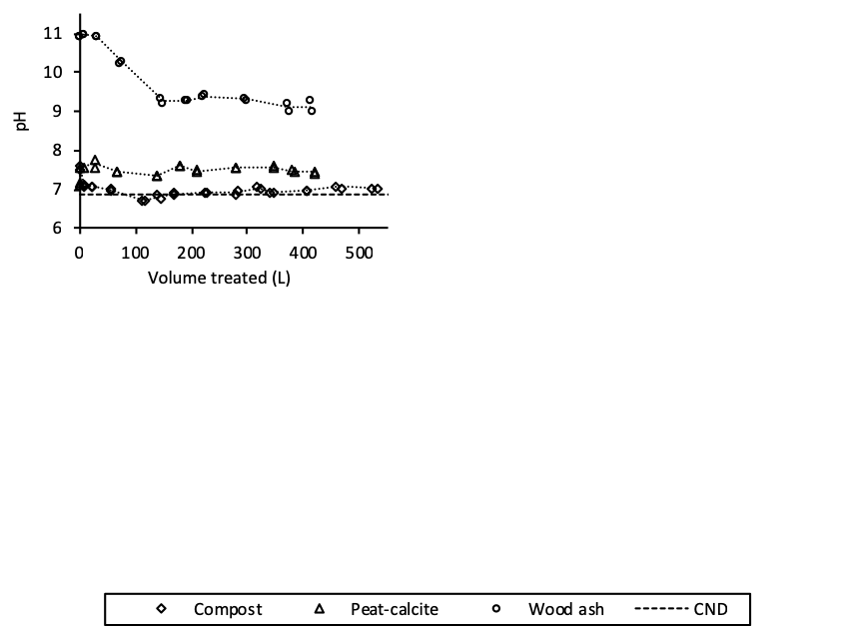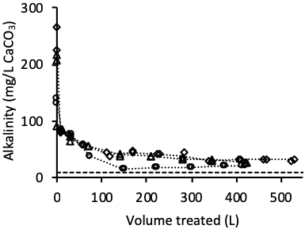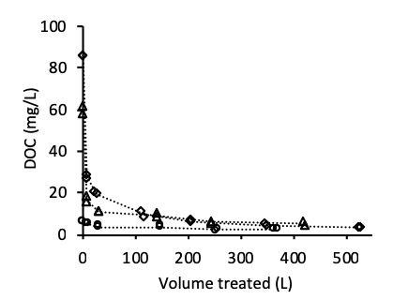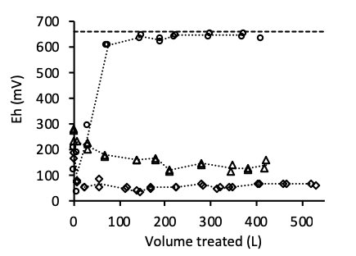

Figure 2 Variation of physicochemical parameters at column outlet port. Mean inflow parameters (when available) are represented by the straight dashed line. Duplicate results are presented for each type of column.

*Column profiles*

The Eh, Fe and sulfides column profiles were built using liquid samples taken from the inlet (0 cm), P1 (9 cm), P2 (18.6 cm), P3 (27.9 cm) and outlet ports (33-35 cm) and represent the inlet, pore water, and outflow conditions within the columns (Fig. 3 & 4). In these figures, the origin of the y axis represents the bottom of the columns. In compost and peat-calcite columns, important Eh decreases (400-550 mV) were observed between the entry and P1 ports in compost columns, and between P2 and P3 ports in peat-calcite columns, likely due to oxygen consumption during organic matter oxidation. For wood ash columns, pore water Eh values remained constant and similar to the entry value for the entire height of the columns. In these columns, Eh measurement was difficult as the electrode’s response would occasionally become erratic, mostly after its prolonged exposure to the wood ash pore water solution, and start to give unstable mV readings. This behavior was corrected at best by frequently recalibrating the electrode. Eh profiles indicated that pore water conditions became more reducing in the bottom of the compost columns and in the second half of the peat-calcite columns, while they remained highly oxidizing in the wood ash column.

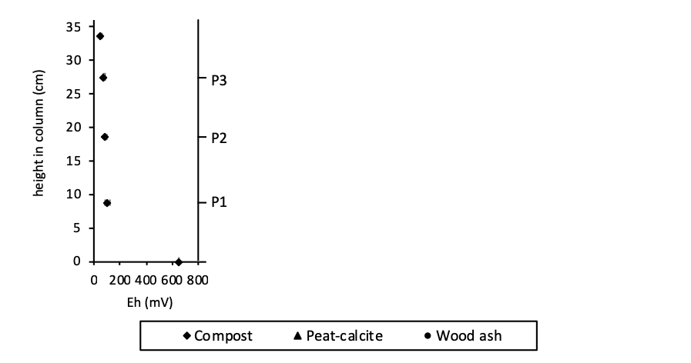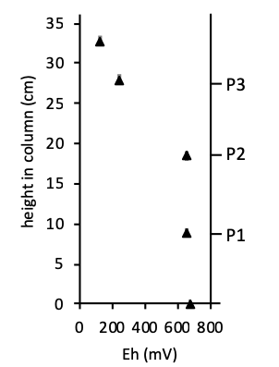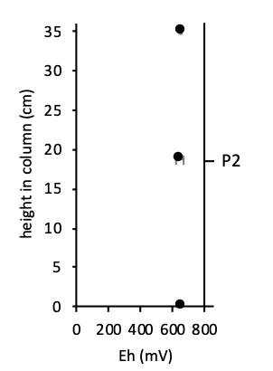

Figure 3 Mean Eh measurements in liquid samples taken from column ports at time =11 weeks. Results are presented as the average parameter from duplicate columns with error bars representing one standard deviation from the mean.

Sulfides and Fe, absent from the synthetic CND composition (Table 2), were measured in the compost and peat-calcite column outflows (Fig. 4) but remained below detection limits in wood ash columns (data not shown). Final sulfide and Fe profiles in compost and peat-calcite columns showed an increase in these parameters with height in the columns. Low sulfide concentrations (< 110 μg/L), detected at port P1 in the compost columns and at port P3 in the peat calcite columns, were measured in samples when Eh values fell below 250 mV. In compost columns, sulfide concentrations decreased between P3 and outlet ports probably due to the precipitation of black metastable Fe-sulfides (Fig. S8, SI). Furthermore, the Eh values measured at the P3 (73 mV) and outlet ports (50 mV) of compost columns suggested early stage sulfate-reducing conditions (Fig. 3), even though sulfate concentrations at the outlet remain relatively constant (Fig. S6, SI). Pore water Fe concentrations were much lower in peat-calcite columns due to the lower Fe content of this material (Table S1, SI), and Fe-sulfide precipitates were not observed in these columns. In compost columns, the treated water Fe concentration decreased with time (Fig. S6, SI), as reducible Fe was likely decreasing in the solid. Total Fe concentrations in the spent compost samples collected after dismantlement indicated that Fe concentrations were lower (15900 ± 200 mg/kg) in the bottom sections of the columns than in the upper sections (18900 ± 900 mg/kg), where concentrations remained similar to the initial Fe content of the compost (Table S1, SI).

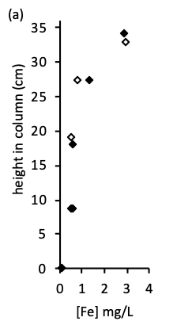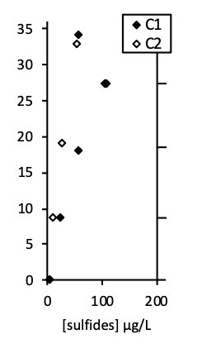

P3

P2

P1

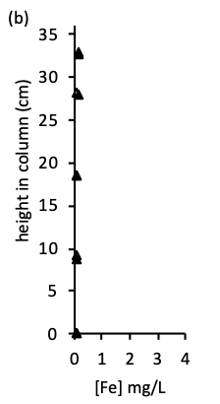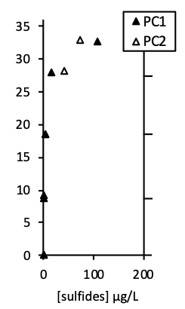

P3

P2

P1

Figure 4 Final pore water Fe and sulfides concentrations in (a) compost columns (time = 17 weeks) and (b) peat-calcite columns (time = 11 weeks)

*Post-testing characterization*

The fresh materials characteristics are presented along with the post-experiment characterizations for each column (Table 3). The pH of the spent solid in peat-calcite and wood ash columns was lower than the initial pH of the material by up to 1.16 pH units and 1.75 pH units, respectively. This decrease in pH was likely due to the dissolution of calcite and other pH increasing minerals during the experiment. It was more pronounced in the bottom layers of columns than in the top layers, with a larger difference in the peat-calcite columns (0.62 pH units) than in the wood ash columns (0.33 pH units). The pH of the spent compost was identical within two standard deviations to the initial compost pH in all samples except for the bottom sample in C1 in which the pH was slightly higher (0.31 pH units). The DOC of the spent solid was lower than the initial DOC of the material in all columns which is consistent with the continuous DOC loss at the column outlet (Fig. 2). In compost and peat calcite columns, higher DOC values were measured in the top layers than in the bottom layers, while they remained constant and low in wood ash columns. The CTOT was relatively constant between the spent materials and the materials. The total inorganic C, calculated as the difference between CTOT and Corg+g,was higher in the top sections of the wood ash and peat-calcite columns than in the bottom sections, which may be related to the more pronounced dissolution of carbonates in bottom sections.Both CEC and SSA values are traditionally presented on a weight basis but for fixed volume applications, it is relevant to compare these values on a volume basis. On this basis, the CEC of the fresh material increased in the order: wood ash < peat < compost, while the SSA, better correlated to the performance of the different materials in the present study, increased in the order: peat < compost < wood ash. The rate of sorption processes on porous solids such as wood ash is determined by intra-particle diffusion and may require days to reach a steady state (Inglezakis et al. 2019; Rees et al. 2014; Richard et al. 2020b; Tran et al. 2017). Hence the CEC experimental protocol used in the present study (Chapman 1965), where substrates and solutions are equilibrated at fixed pH (8.2) over short time periods (3 x 5 min), might not be best suited to evaluate the removal potential of this type of solid.

Table 3 Physicochemical characterization of fresh and post-treatment organic materials

|  |  |  |  |  |  |  |  |  |  |  |  |  |  |  |  |  |  |  |  |
| --- | --- | --- | --- | --- | --- | --- | --- | --- | --- | --- | --- | --- | --- | --- | --- | --- | --- | --- | --- |
|  |  |  | | | pH | | Water content  (% w/w) | | DOC - water ext. (mg/L) | CTOT  (% w/w) | | Corg+g (% w/w) | | Cinorg (% w/w) | | CEC (meq/100g) / (meq/cm3) | | SSA  (m2/g) / (m2/cm3) | |
|  |  |  | | |  | |  | |  |  | |  | |  | |  | |  | |
| Wood ash | Fresh materials1 | | | | 10.74 ± 0.2 | | - | | 64.4 ± 8.0 | 48.6 ± 0.6 | | 41.7 ± 2.0 | | 6.9 ± 2.5 | | 100 ± 5 / 0.25 ± 0.01 | | 94.4 / 23.4 | |
|  |  | | |  | |  | |  |  | |  | |  | |  | |  | |
| Post-treatment materials | WA1 (Bottom)  WA1 (Top) | | | 8.99 | | 76.6 | | 4.5 | 54.6 | | 46.4 | | 8.2 | | - | | - | |
| 9.31 | | 70.9 | | 4.7 | 53.9 | | 37.6 | | 16.3 | | - | | - | |
| WA2 (Bottom)  WA2 (Top) | | | 9.12 | | 73.7 | | 2.5 | - | | - | | - | | - | | - | |
| 9.45 | | 71.0 | | 1.5 | - | | - | | - | | - | | - | |
|  |  |  |  |  | |  | |  | | |  | |  | |  | |  | |  | |
| Compost | Fresh materials1 | | | | 7.98 ± 0.12 | | - | | 71.4 ± 3.6 | 16.8 ± 1.3 | | 13.0 ± 2.3 | | 3.8 ± 3.7 | | 64 ± 5 / 0.42 ± 0.03 | | 5.88 / 3.86 | |
| Post-treatment materials | C1 (Bottom)  C1 (Top) | | | 8.29 | | 51.8 | | 8.2 | - | | - | | - | | - | | - | |
| 8.13 | | 49.9 | | 13.1 | - | | - | | - | | - | | - | |
| C2 (Bottom)  C2 (Top) | | | 8.18 | | 50.1 | | 9.5 | 18.9 | | 16.5 | | 2.4 | | - | | - | |
| 8.10 | | 47.0 | | 11.2 | 17.3 | | 14.9 | | 2.4 | | - | | - | |
|  |  |  |  |  | |  | |  | | |  | |  | |  | |  | |  | |
| Peat | Fresh materials1 | | | | 5.07 ± 0.12 | | - | | 251 ± 6 | 50.2 ± 1.0 | | 50.6 ± 0.1 | | 0 ± 1 | | 195 ± 4 / 0.40 ± 0.01 | | 1.52 / 0.31 | |
|  |  | | | |  | |  | |  |  | |  | |  | |  | |  | |
| Peat-calcite | Fresh materials1 | | | | 8.41 ± 0.12 | | - | | - | - | | - | | - | | - | | - | |
| Post-treatment materials | PC1 (Bottom)  PC1 (Top) | | | 7.25 | | 79.6 | | 6.5 | - | | - | |  | | - | | - | |
| 7.87 | | 76.9 | | 18.4 | - | | - | |  | | - | | - | |
| PC2 (Bottom)  PC2 (Top) | | | 7.30 | | 80.8 | | 7.7 | 50.4 | | 48.1 | | 2.3 | | - | | - | |
| 7.91 | | 77.6 | | 19.9 | 49.6 | | 40.5 | | 9.1 | | - | | - | |

1 Results are expressed as mean ± standard deviation using n=2 (DOC, CTOT, Corg+g, n=3 (pH, CEC).

*Chemical extractions following sequestration on spent organic materials*

The sum of Ni concentrations in extraction solutions following the SEP are presented along with total digestion results (Table 4). Results of these extractions indicate that more Ni was retained in the bottom sections of the columns than in the top sections, and that top section Ni concentations were only slighlty higher (20-85 mg/kg) than fresh material Ni concentrations (Table S1). Middle section Ni concentrations were higher in the order peat-calcite > compost > wood ash, as expected based on final mid-column pore-water Ni concentrations (Fig. S7, SI). Results of the SEP (Fig.5 & Table S2, SI) indicated that the fractionnation of Ni differred between the top and bottom sections of columns. The residual fraction (F5) was proportionnally lower in the bottom sections of all columns as the other fractions in this section retained most of the Ni. The Ni content of the residual fraction mainly originates from the material istself and thus, it is logical that this fraction decreased in comparison to the other fractions as it did not retain additionnal Ni. In bottom sections of wood ash columns, Ni was retained predominantly on the reducible or bound to Fe-Mn oxides fraction (F3) (in agreement with mean Eh measurements in Fig. 3). The absence of Mn in wood ash column outflows (Fig. S6, SI) suggests that Mn was retained in these columns, possibly in the form of oxides or oxyhydroxides, and may have contributed to Ni removal. In bottom sections, the proportion of Ni in the labile or mobile fraction (F1 + F2), representing the fraction that could become an environmental risk (Gosselin and Zagury 2020; Pinto and Al-Abed 2017), was lower in the wood ash (23%) columns than in the compost (37 %) and peat-calcite (36%) columns. When compared to their respective top sections, a higher percentage of Ni was associated to the mobile fraction in bottom sections of the compost (C1 and C2) and peat-calcite (PC1) columns suggesting retention mechanisms such as ion exchange and specific adsorption in compost and peat-calcite.

Table 4 Ni concentrations in extracting solutions following SEP and total digestion of spent organic materials

|  |  |  |  |
| --- | --- | --- | --- |
|  |  | Sum of [Ni] in SEP (mg/kg)1 | Total digestion [Ni] (mg/kg)1 |
|  |  |  |  |
| Wood ash | Bottom | 3490 ± 710 | 3960 ± 630 |
|  | Middle (WA1) | 55 | 44 |
|  | Top | 66 ± 9 | 49 ± 2 |
|  |  |  |  |
| Compost | Bottom | 3290 ± 200 | 2990 ± 170 |
|  | Middle (C2) | 317 | 337 |
|  | Top | 51 ± 11 | 52 ± 17 |
|  |  |  |  |
| Peat-calcite | Bottom | 4910 ± 290 | 4250 ± 140 |
|  | Middle (PC2) | 2270 | 1980 |
|  | Top | 55 ± 41 | 43 ± 26 |

1Results are expressed as mean ± standard deviation using n = 2 (duplicate columns), except for the mid-column samples for which only one column was sampled.

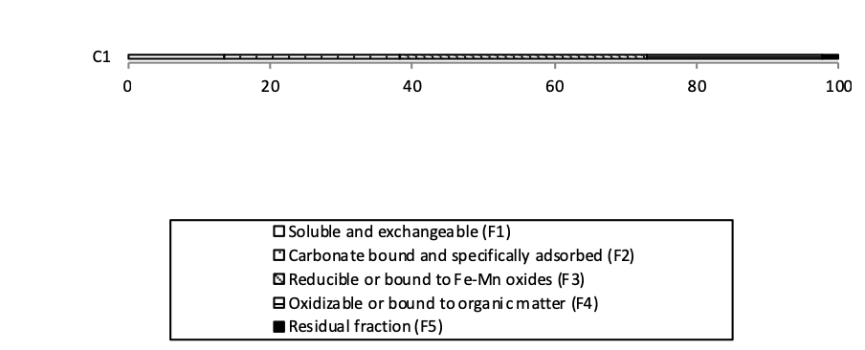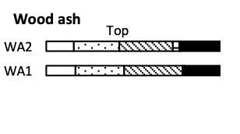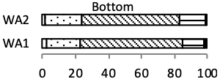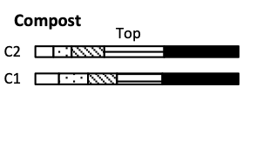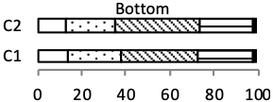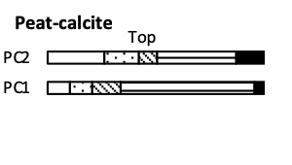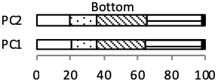

Figure 5 Fractionation of Ni, according to the SEP applied to spent organic materials sampled from bottom and top sections of columns at dismantlement.

*Column performance, substrate properties and scale-up*

The SSA values of compost and peat (Table 3) were lower than that of wood ash and yet, in short-term (1 day) batch experiments, under circum-neutral conditions, these materials adsorbed more Ni than wood ash because of their organic surface functional groups (Richard et al. 2020a). At higher pH (8) and longer exposure times (more than 2 days), the Ni removal efficiency of wood ash increased in batch experiments and the three materials performed equally well (Richard et al. 2020b). In the present study, pH values of wood ash effluent were 1.75 to 4 pH unit higher than those of compost and peat-calcite columns (Fig. 2), due to the higher solid: solution ratios in column experiments in comparison to batch tests. At higher pH, the net solid surface charge becomes more negative, and the sorption of cationic metals onto solids is typically increased. Hence the combination of high pH and high SSA values might explain to some extent the better performance of wood ash columns versus compost and peat-calcite columns. A high pH material (peat fly ash) was also observed to outperform compost for the removal of metal cations (Zn, Cd, Pb) in a field study by Warrender et al. (2011).

When the pH of the synthetic CND is increased above 7.79, oversaturated Ni carbonate (NiCO3(s), Ksp = 10-11.2) and hydroxide (Ni(OH)2(c),ksp = 10-10.79) phases become dominant over the dissolved Ni species, for closed system conditions and in the absence of a solid substrate. Hence, in high pH columns, Ni could be removed via precipitation mechanisms. While ksat decreased by one order of magnitude in wood ash columns during the experiment (Table 1), newly formed precipitates were not observed upon dismantlement or during the SEM-EDS analysis.

During the two week high pH phase at the beginning of the wood ash experiment, a small amount of white precipitate, presumably calcite, formed in the treated water upon their exposure to atmospheric conditions. During this period, calcite saturation indexes (SIcalcite) were >1.5 (Fig. S9, SI), a threshold value above which calcite precipitation in solution can be expected (Ford and Williams 2007; Riley and Mayes 2015). This is a concern with the use of alkaline materials such as wood ash as calcite precipitation in the treated water may smother benthic habitats and affect fish and invertebrate populations (Bogart et al. 2016; Hull et al. 2014; Koryak et al. 2002). In compost columns, treated water was oversaturated with respect to a suite of Fe oxides, and rust color precipitates were observed in all samples upon their aeration.

The ratios between the volumes of CND treated when mid-column Ni breakthrough was reachedand the volume of material in the lower section of columns (below P2) were scaled linearly to estimate the approximate volume of each material that would be required to maintain a Ni contaminated effluent (4.05 mg/L Ni) with a flow rate of 10 m3/h below breakthrough (< 0.5 mg/L Ni) for a period of one year. The estimated volumes of materials required for compost (600 ± 140 m3) and peat-calcite (720 ± 50 m3) treatment cells were relatively close, as the low Ni breakthrough concentration (0.5 mg/L) intersects the very bottom of the S-shaped curves (Fig. 1-B). Results from the wood ash columns only allowed the prediction of an upper limit (< 500 m3) to the volume of material required for a treatment cell.

**Conclusion**

Compost, peat-calcite and wood ash column reactors (4.8 L) continuously treated more than 400 L of synthetic CND containing 4.05 mg/L of Ni over a period of 11 to 14 weeks at HRTv of ∼ 16.5 hours. Reducing conditions were observed in compost and peat-calcite columns with suggestion of early stages of sulfate reduction and metal sulfide precipitation, for compost columns only. At the end of columns’ operation, Ni breakthrough (0.5 mg/L Ni) was reached at mid-column (HRTvP2 ∼ 9h) in peat-calcite and compost columns while increasing Ni concentrations (up to 0.22 mg/L) were measured in wood ash columns. Column performance increased in the order peat-calcite < compost < wood ash and a sequential extraction procedure suggested that the sequestered Ni was potentially less mobile in the wood ash residue than in the other spent organic materials. Sorption is thought to be the main Ni removal mechanism in the lower, Ni-rich, sections of columns and the better performance of wood ash was attributed to the pH increasing properties of this material. Precipitation of hydroxides or carbonates may also have contributed to Ni removal in these high pH columns. The depletion of pH increasing minerals, or the precipitation of sulfides may affect Ni removal capacities in the upper section of columns (between HRTv of ∼ 9 hours and ∼ 16.5 hours), and further testing is warranted to evaluate the performance of the materials at longer HRT. Scaling the mid-column results to full-scale showed that cell sizes designed for a one-year treatment of a high discharge (10 m3/h) Ni contaminated (4.05 mg/L) neutral effluent would vary between less than 500 m3 for wood ash and 720 ± 50 m3 for peat-calcite. Further investigations are needed to assess whether cell sizes could be reduced via material compaction and whether the use of higher water velocities would affect Ni removal capacities. Moreover multi-step treatment systems might be an option worth investigating for the passive treatment of CND. These systems could take advantage of the removal capacity of wood ash as a first step and of the low pH of peat as a second step for additional adsorption and pH adjustment.

**Declarations**

**Ethics approval and consent to participate**

Not applicable

**Consent for publication**

Not applicable

**Availability of data and materials**

All data generated or analyzed during this study are included in this published article and its supplementary information file.

**Competing interests**

The authors declare that they have no competing interests.

**Funding**

This study was funded by the NSERC (Natural Sciences and Engineering Research Council of Canada), grant no. 469489-14, and the industrial partners of the RIME UQAT Polytechnique Montreal, including Agnico Eagle, Mine Canadian Malartic, Iamgold, Raglan Mine Glencore, and Rio Tinto.

**Authors' contributions**

DR participated in the conceptualization of the project and performed the experiments. She wrote the methodology, analyzed the data and wrote the original draft. DR also reviewed and edited the manuscript. CMN participated in project conceptualization and data interpretation. CMN also reviewed and edited the manuscript. GJZ conceptualized and supervised the project, participated in the development of the methodology, analyzed the data, co-wrote, reviewed and edited the final manuscript. All authors read and approved the final manuscript.

**Acknowledgements**

DR wishes to acknowledge support from the "Fonds de recherche Nature et technologies" (FQRNT) graduate scholarship program and from the "Fondation et alumni de Polytechnique Montréal" (Bourse Banque de Montréal).

**References**

Ali A, Gupta VK (2006) Advances in water treatment by adsorption technology Nature Protocols 1:2661-2667

APHA (1998) Standard methods for the examination of water and wastewater. 20th edn. American Public Health Association, Washington, D.C.

APHA (2005) Standard methods for the examination of water and wastewater. 21st edn. American Public Health Association, Washington, D.C.

ASTM (2000) 2434-68 —Standard Test Method for Permeability of Granular Soils (Constant Head). In: Annual book of ASTM standards. West Conshohocken, PA,

ASTM (2014) D854-14, - Standard Test Method for Specific Gravity of Soil Solids by Water Pycnometer. In: Annual book of ASTM standards. West Conshohocken, PA,

Bogart SJ, Woodman S, Steinkey D, Meays C, Pyle GC (2016) Rapid changes in water hardness and alkalinity: Calcite formation is lethal to Daphnia magna Science of the Total Environment 559:182-191 doi:10.1016/j.scitotenv.2016.03.137

Brunauer S, Emmett PH, Teller E (1938) Adsorption of gases in multimolecular layers Journal of the American Chemical Society Soc 60:309-319

Calugaru IL, Neculita CM, Genty T, Bussiere B, Potvin R (2017) Removal of Ni and Zn in contaminated neutral drainage by raw and modified wood ash Journal of Environmental Science and Health, Part A 52:117-126 doi:10.1080/10934529.2016.1237120

Calugaru IL, Neculita CM, Genty T, Zagury GJ (2018) Metals and metalloids treatment in contaminated neutral effluents using modified materials Journal of Environmental Management 212:142-159 doi:10.1016/j.jenvman.2018.02.002

CEAEQ (2013) Détermination du carbone et du soufre: méthode par combustion et dosage par spectrophotométrie infrarouge, Méthode MA.310-CS 1.0. <http://www.ceaeq.gouv.qc.ca/methodes/pdf/MA310CS10.pdf>. Accessed 2019-06-18 2019

CEAEQ (2014) Détermination du carbone organique total dans les solides: dosage par titrage, Méthode MA. 405 - C 1.1. <http://www.ceaeq.gouv.qc.ca/methodes/pdf/MA310CS10.pdf>. 2018

CEAEQ (2019) Détermination de l'alcalinité et de l'acidité: méthode titrimétrique automatisée, Méthode MA. 315 - Alc-Aci 1.0. <http://www.ceaeq.gouv.qc.ca/methodes/pdf/MA315AlcAc10.pdf>. Accessed 2019-06-18 2019

Chapman HD (1965) Cation exchange capacity. In: Black CA (ed) Methods of Soil Analysis. American Society of Agronomy, Madison, Wis, pp 891-901

Chapuis RP, Baass K, Davenne L (1989) Granular soils in rigid-wall permeameters - method for determining the degree of saturation Canadian Geotechnical Journal 26:71-79 doi:10.1139/t89-008

Claveau-Mallet D, Wallace S, Comeau Y (2012) Model of phosphorus precipitation and crystal formation in electric arc furnace steel slag filters Environmental Science and Technology 46:1465-1470 doi:10.1021/es2024884

Courcelles B, Modaressi-Farahmand-Razavi A, Gouvenot D, Esnault-Filet A (2011) Influence of precipitates on hydraulic performance of permeable reactive barrier filters International Journal of Geomechanics 11:142-151 doi:10.1061/(asce)gm.1943-5622.0000098

de Repentigny C, Courcelles B, Zagury GJ (2018) Spent MgO-carbon refractory bricks as a material for permeable reactive barriers to treat a nickel- and cobalt-contaminated groundwater Environmental Science and Pollution Research 25:23205-23214 doi:10.1007/s11356-018-2414-3

Demeyer A, Nkana JCV, Verloo MG (2001) Characteristics of wood ash and influence on soil properties and nutrient uptake: an overview Bioresource Technology 77:287-295 doi:10.1016/s0960-8524(00)00043-2

Ford DC, Williams PW (2007) Karst Geomorphology amf Hydrology. Unwin Hyman, London, UK

Genty T, Bussiere B, Benzaazoua M, Zagury GJ (2012) Capacity of wood ash filters to remove iron from acid mine drainage: Assessment of retention mechanism Mine Water and the Environment 31:273-286 doi:10.1007/s10230-012-0199-z

Gosselin M, Zagury GJ (2020) Metal(loid)s inhalation bioaccessibility and oxidative potential of particulate matter from chromated copper arsenate (CCA)-contaminated soils Chemosphere 238 doi:10.1016/j.chemosphere.2019.124557

Gustafsson JP (2019) Visual MINTEQ ver. 3.1 <https://vminteq.lwr.kth.se/>. Accessed 2019-02-01 2019

Hengen TJ, Squillace MK, O’Sullivan AD, Stone JJ (2014) Life cycle assessment analysis of active and passive acid minedrainage treatment technologies Resources, Conservation and Recycling 86:160-167 doi:10.1016/j.resconrec.2014.01.003

Hull SL, Oty UV, Mayes WM (2014) Rapid recovery of benthic invertebrates downstream of hyperalkaline steel slag discharges Hydrobiologia 736:83-97 doi:10.1007/s10750-014-1894-5

Inglezakis VJ, Fyrillas MM, Park J (2019) Variable diffusivity homogeneous surface diffusion model and analysis of merits and fallacies of simplified adsorption kinetics equations Journal of Hazardous Materials 367:224-245 doi:10.1016/j.jhazmat.2018.12.023

Komonweeraket K, Cetin B, Benson CH, Aydilek AH, Edil TB (2015) Leaching characteristics of toxic constituents from coal fly ash mixed soils under the influence of pH Waste Management 38:174-184 doi:10.1016/j.wasman.2014.11.018

Koryak M, Stafford LJ, Reilly RJ, Magnuson MP (2002) Impacts of steel mill slag leachate on the water quality of a small Pennsylvania stream Journal of Freshwater Ecology 17:461-465 doi:10.1080/02705060.2002.9663921

Malamis S, Katsou E (2013) A review on zinc and nickel adsorption on natural and modified zeolite, bentonite and vermiculite: Examination of process parameters, kinetics and isotherms Journal of Hazardous Materials 252-253:428-461

Neculita CM, Zagury GJ, Bussière B (2007) Passive treatment of acid mine drainage in bioreactors using sulfate-reducing bacteria: Critical Review and Research Needs Journal of Environmental Quality 36:1-16 doi:10.2134/jeq2006.006

Neculita CM, Zagury GJ, Bussière B (2008) Effectiveness of sulfate-reducing passive bioreactors for treating highly contaminated acid mine drainage: II. Metal removal mechanisms and potential mobility Applied Geochemistry 23:3545-3560 doi:10.1016/j.apgeochem.2008.08.014

Nordstrom DK, Blowes DW, Ptacek CJ (2015) Hydrogeochemistry and microbiology of mine drainage: An update Applied Geochemistry 57:3-16 doi:10.1016/j.apgeochem.2015.02.008

Ohno T (1992) neutralization of soil acidity and release of phosphorus and potassium by wood ash Journal of Environmental Quality 21:433-438 doi:10.2134/jeq1992.00472425002100030022x

Peregoedova A (2013) Étude expérimentale des propriétés hydrogéologiques des roches stériles à une échelle intermédiaire de laboratoire. M.Sc.A., École Polytechnique, Montréal (Canada)

Pinto PX, Al-Abed SR (2017) Assessing metal mobilization from industrially lead-contaminated soils located at an urban site Applied Geochemistry 83:31-40 doi:10.1016/j.apgeochem.2017.01.025

Rees F, Simonnot MO, Morel JL (2014) Short-term effects of biochar on soil heavy metal mobility are controlled by intra-particle diffusion and soil pH increase European Journal of Soil Science 65:149-161 doi:10.1111/ejss.12107

Richard D, Mucci A, Neculita CM, Zagury GJ (2020a) Comparison of organic materials for the passive treatment of synthetic neutral mine drainage contaminated by nickel: Adsorption and desorption kinetics and isotherms Water Air and Soil Pollution (accepted)

Richard D, Mucci A, Neculita CM, Zagury GJ (2020b) Comparison of organic materials for the passive treatment of synthetic neutral mine drainage contaminated by nickel: Short- and medium-term batch experiments Applied geochemistry (accepted)

Richard D, Sundby B, Mucci A (2013) Kinetics of manganese adsorption, desorption, and oxidation in coastal marine sediments Limnology and Oceanography 58:987-996 doi:10.4319/lo.2013.58.3.0987

Riley AL, Mayes WM (2015) Long-term evolution of highly alkaline steel slag drainage waters Environmental Monitoring and Assessment 187 doi:10.1007/s10661-015-4693-1

Sauty JP (1980) Analysis of hydrodispersive transfer in aquifers Water Resources Research 16:145-158

Skousen J, Zipper CE, Rose A, Ziemkiewicz PF, Nairn R, McDonald LM, Kleinmann RL (2017) Review of passive systems for acid mine drainage treatment Mine Water and the Environment 36:133-153

Stokes P (1988) Nickel in Aquatic systems. In: Sigel H, Sigel, A. (ed) Metal ions in biological systems: Nickel and its role in biology, vol 23. Marcel Dekker, New York, pp 31-46

Tessier A, Campbell PGC, Bisson M (1979) Sequential extraction procedure for the speciation of particulate trace metals Analytical Chemistry 51:844-851

Tran HN, You S-J, Hosseini-Bandegharaei A, Chao H-P (2017) Mistakes and inconsistencies regarding adsorption of contaminants from aqueous solutions: a critical review Water research 120:88-116 doi:10.1016/j.watres.2017.04.014

Trumm D, Pope J (2015) Passive treatment of neutral mine drainage at a metal mine in New Zealand using an oxidizing system and slag leaching bed Mine Water and the Environment 34:430-441 doi:10.1007/s10230-015-0355-3

Ulery AL, Graham RC, Amrhein C (1993) Wood-ash composition and soil-ph following intense burning Soil Science 156:358-364 doi:10.1097/00010694-199311000-00008

Warrender R et al. (2011) Field trials of low-cost reactive media for the passive treatment of circum-neutral metal mine drainage in Mid-Wales, UK Mine Water and the Environment 30:82-89 doi:10.1007/s10230-011-0150-8

Zagury GJ, Colombano SM, Narasiah KS, Ballivy G (1997) Neutralization of acid mine tailings by addition of alkaline sludges from pulp and paper industry Environmental Technology 18:959-973 doi:10.1080/09593331808616616